**Experiment No - 08**

===============================================================================

**Author Name :** Vinni Fengade

**Roll No. :** 67

**Sem & Sec :** 7th Sem - CSE [B]

===============================================================================

**Aim :** Demonstrate your understanding of cloud computing concepts and your ability to use CloudSim for simulating a cloud environment to simulate the provisioning of virtual machines, resource allocation, and workload execution. (CO1, CO4).

**Problem Statements:**

Perform the following tasks on CloudSim:

1. Setup of the CloudSim environment.

2. Monitor creation and provisioning of virtual machines, resource utilization and result simulation and analysis for various paramenters using given examples.

3. Also, understand and implement load balancing algorithms via Cloud Analyst in CloudSim environment.

**Task 1:**

Demonstrate the Scalability and Flexibility of VM Resources by modifying the hardware resources from 1 vCPUs, 1GB of RAM, and 30GB to 2 vCPUs, 4GB of RAM, and 30GB.

**Task 2:**

Demonstrate that the created VM instance should be accessible via SSH/PUTTY for administration purposes.

**Task 3:**

Demonstrate the running of an Web application on the Public IP of the VM instance

(Ex: Apache Server)

**===============================================================================**

**Task 1 (Scalability and Flexibility of VM Resources)**

**===============================================================================**

Step 1 -: Launch the AWS Learners Lab and open EC2 -> Instances -> Launch Instance  
Step 2 -: Select the specified configurations

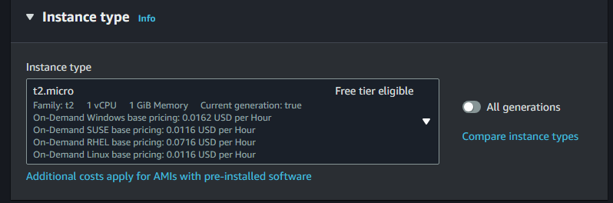 [1 vCPUs, 1GB of RAM, and 30GB of storage]  
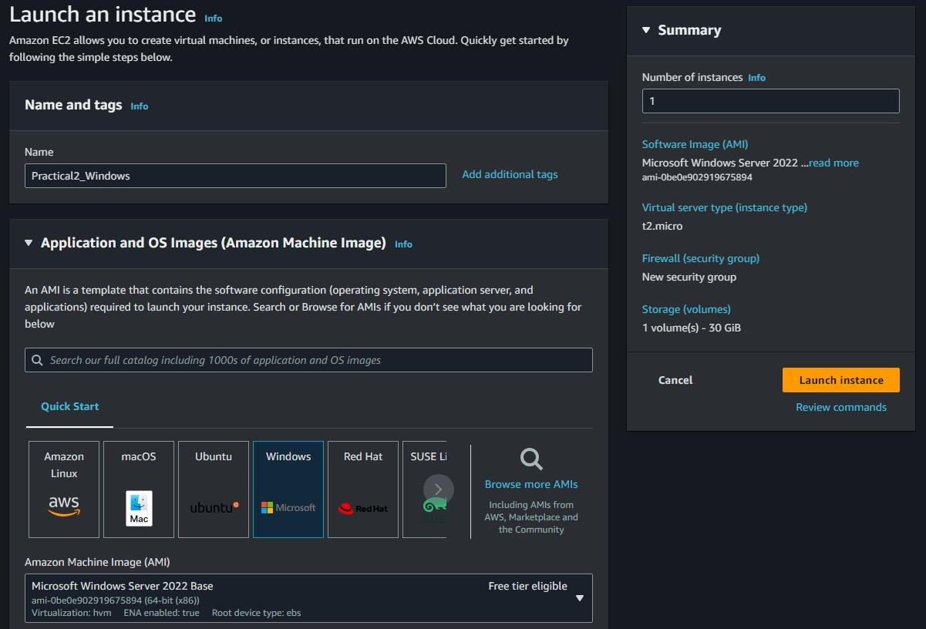

Step 3 -: Configuring Key-Pair for connection to instance.

Click Create new key-pair

For Windows, we need to create key file format as .pem

For Linux, we need to create key file format as .ppk

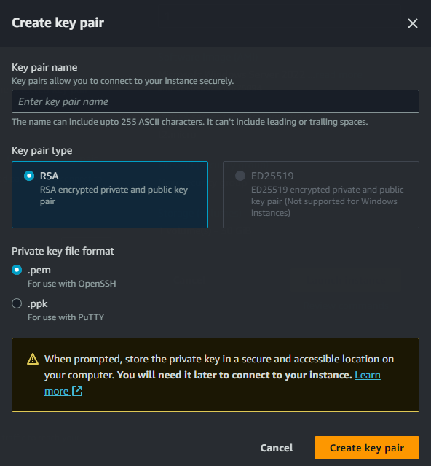Create key pair

For windows, we are required to cre

Then launch the instance.

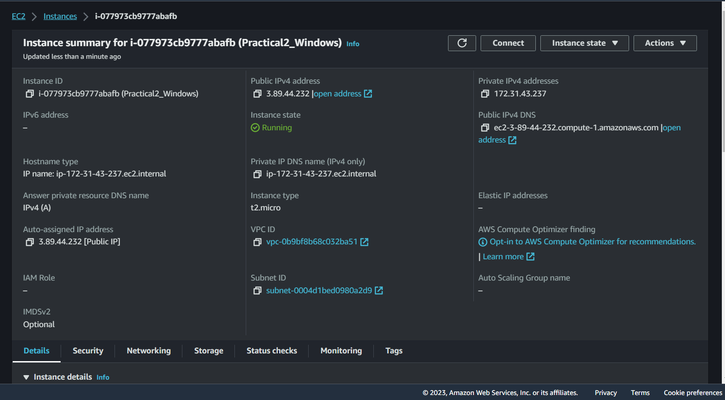

Scaling and Flexible VM Resources

1. Stop the running instance.
2. Change the instance type to t2.medium for specified configuration.

[2 vCPUs, 4GB of RAM, and 30GB]

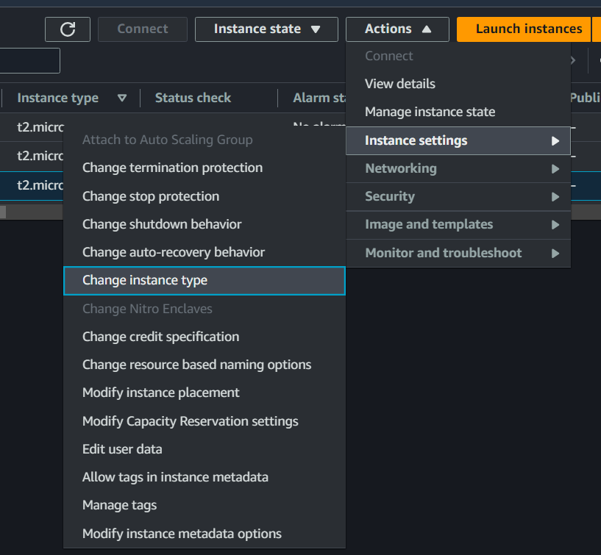

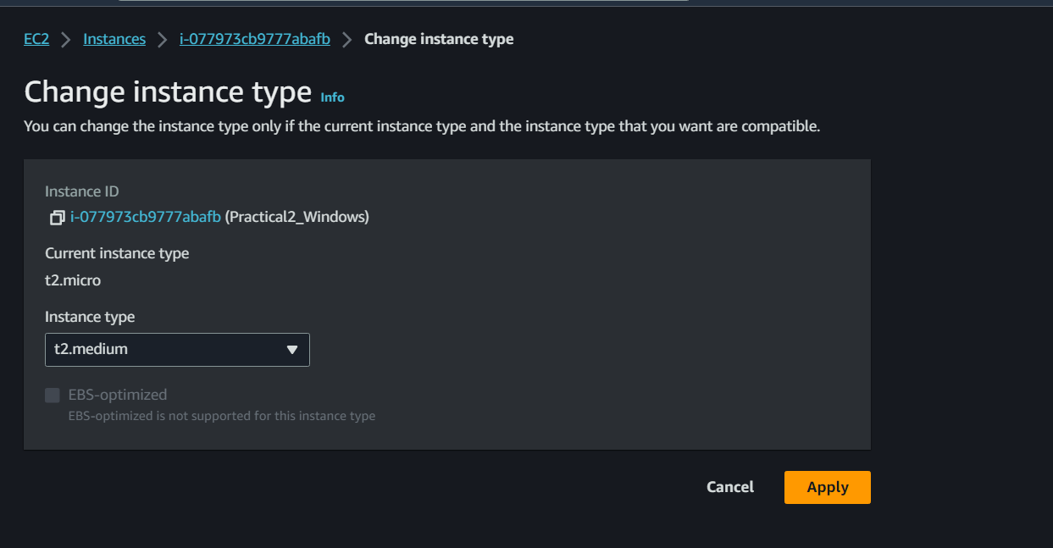

**Connecting to Linux Instance:**

1. For connecting to the system you have to install the putty software After installing the software enter the public host ip in hostip section and in connection tab->SSH->Auth->credentials enter the key and click on open

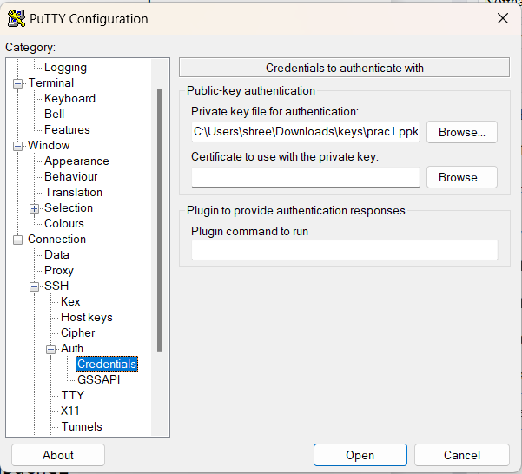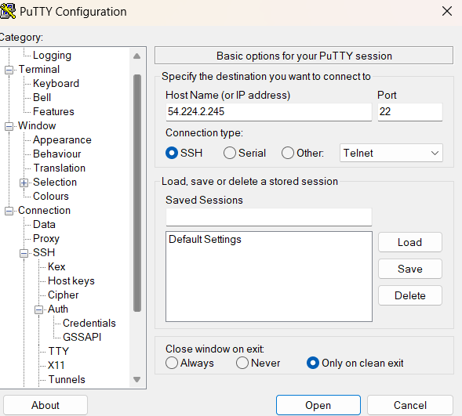

1. 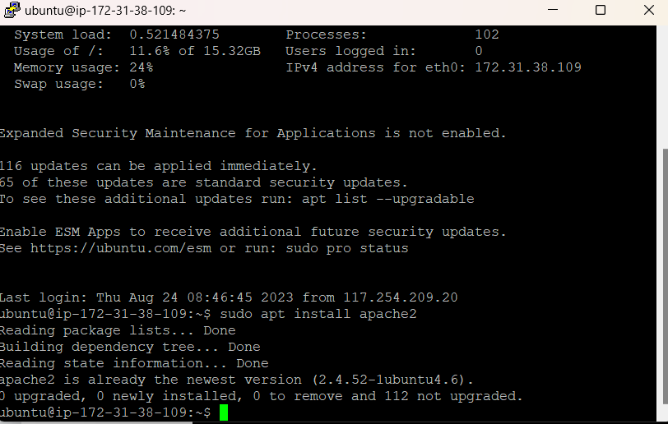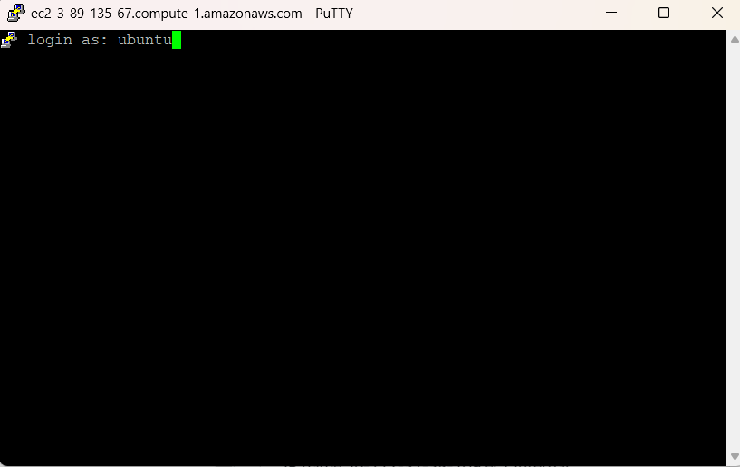Enter the hostname in command line as ubuntu(the name that has been specified) and connect to the vm

**Part B**

Step1:login in your AWS academy learners lab and click on ec2 instance

Step2:click on launch instance

Step3: configure your instance according to your need here for example we have taken windows 7 OS with 2 GB ram 16 GB storage and 1 core then click on launch button

Note: create a access key for connecting to ec2 instance for windows make it in .pem

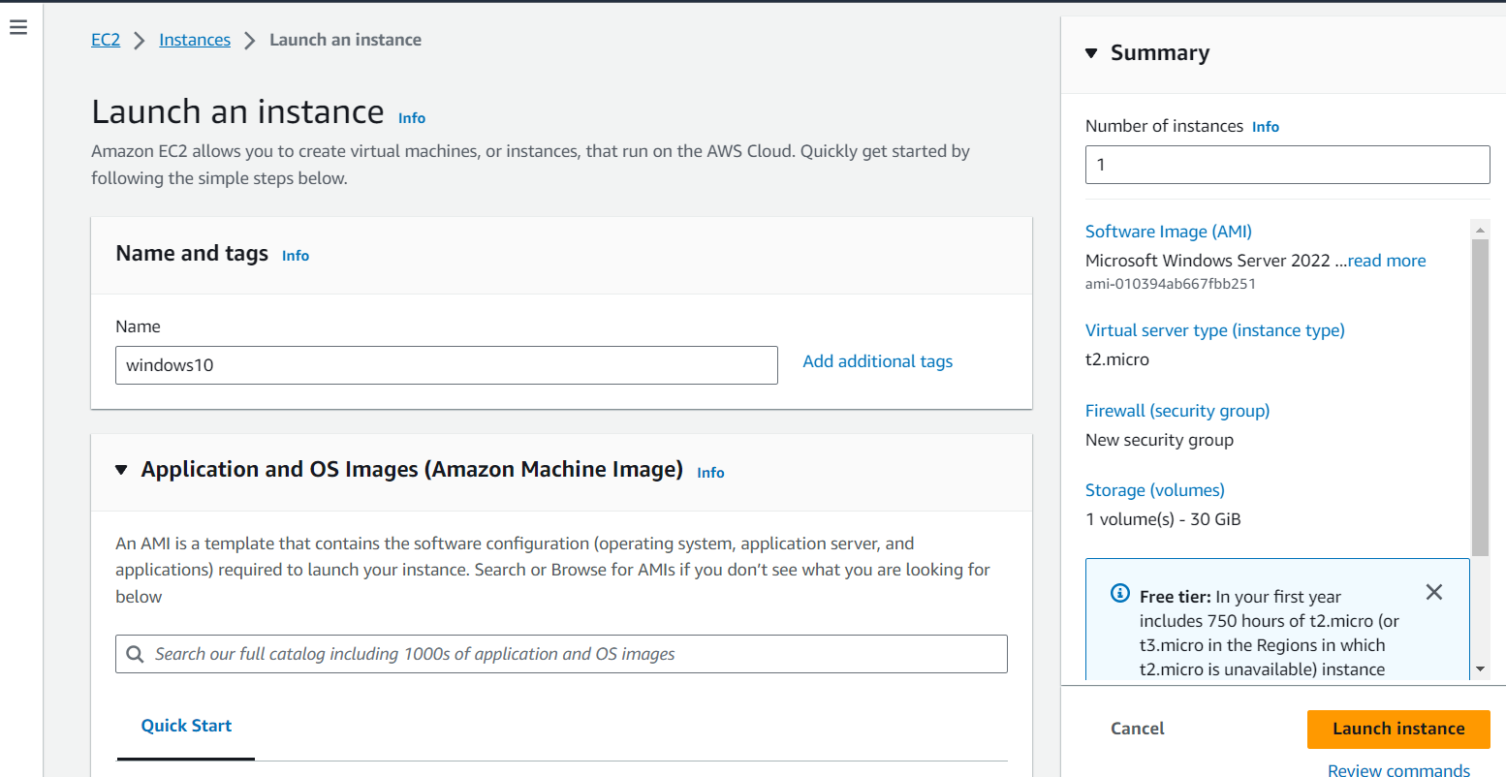

Note : after some time you can change the configuration according to your need

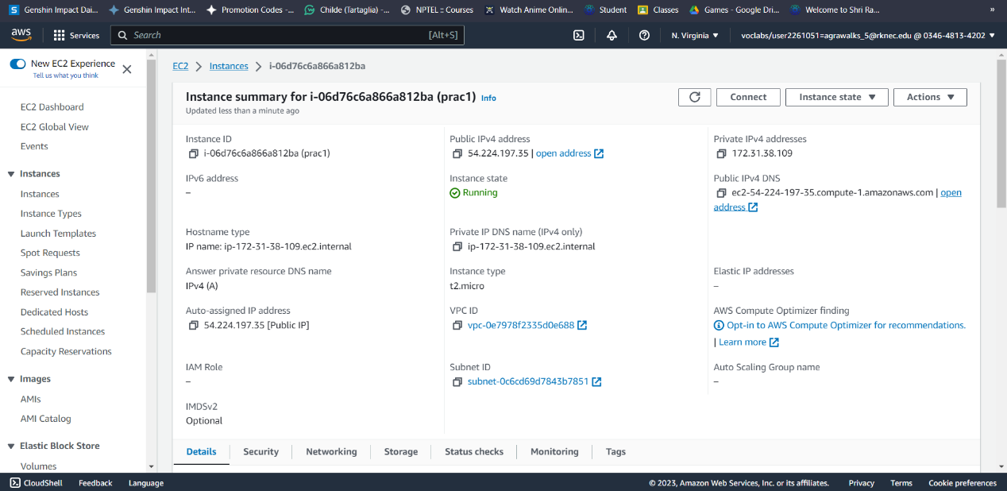

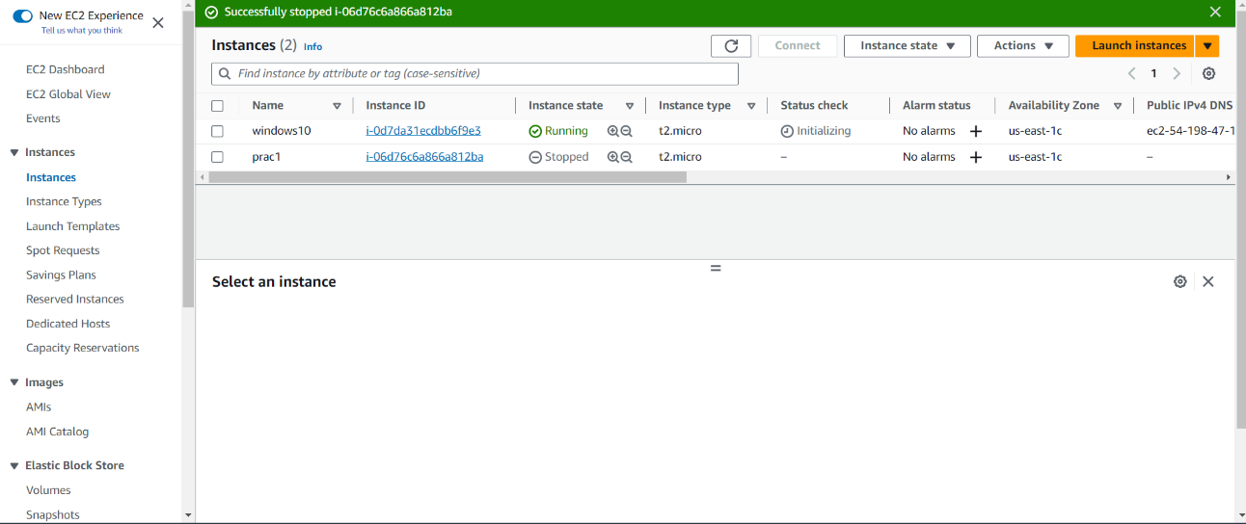

Step4: for connecting to the system click on connect button then decrypt the key that you download and click on connect and enter the key to connect

